SimClock CYD

Scan the QR code below to connect to the SimClock CYD.
SSID: SimClock
Password: simulation
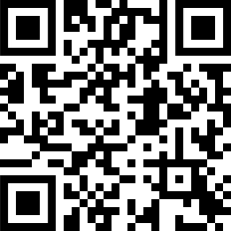

Scan the QR code below if the user interface doesn’t load automatically.
Address: 10.0.0.1


SimClock CYD Control Panel
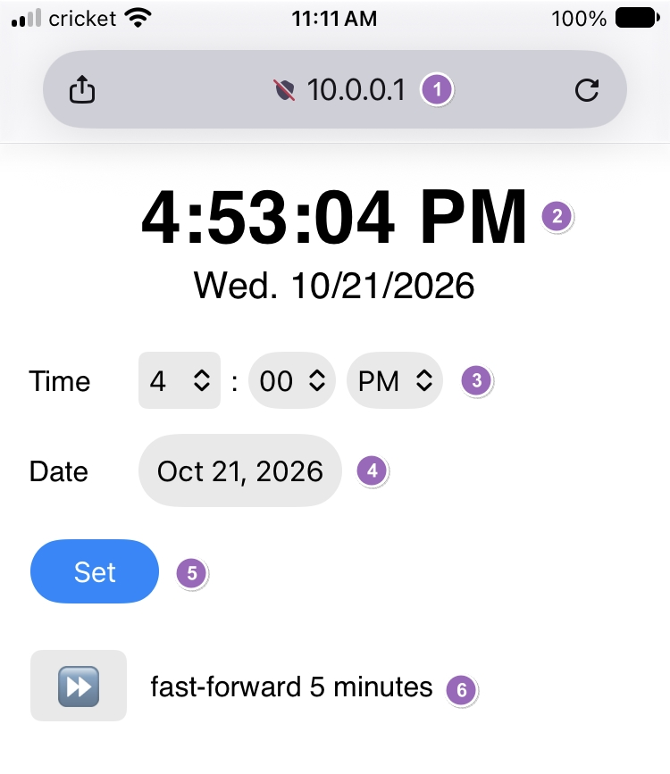
- Once connected to the SimClock CYD, the control panel should automatically load. If it does not, use the QR code above or enter 10.0.0.1 in your browser’s address bar to load the control panel.
- The control panel shows the current time and date displayed on the SimClock CYD in real-time.
- Select the hours, minutes, and AM/PM (auto-filled with current time)
- Select the date (auto-filled with current date)
- Set the clock to the time and date selected above. Seconds are automatically set to zero. ¡Tip! Select the time and date above prior to starting simulation and tap “Set” when you’re ready to begin.
- Fast-forward the simulated time by five minutes.

